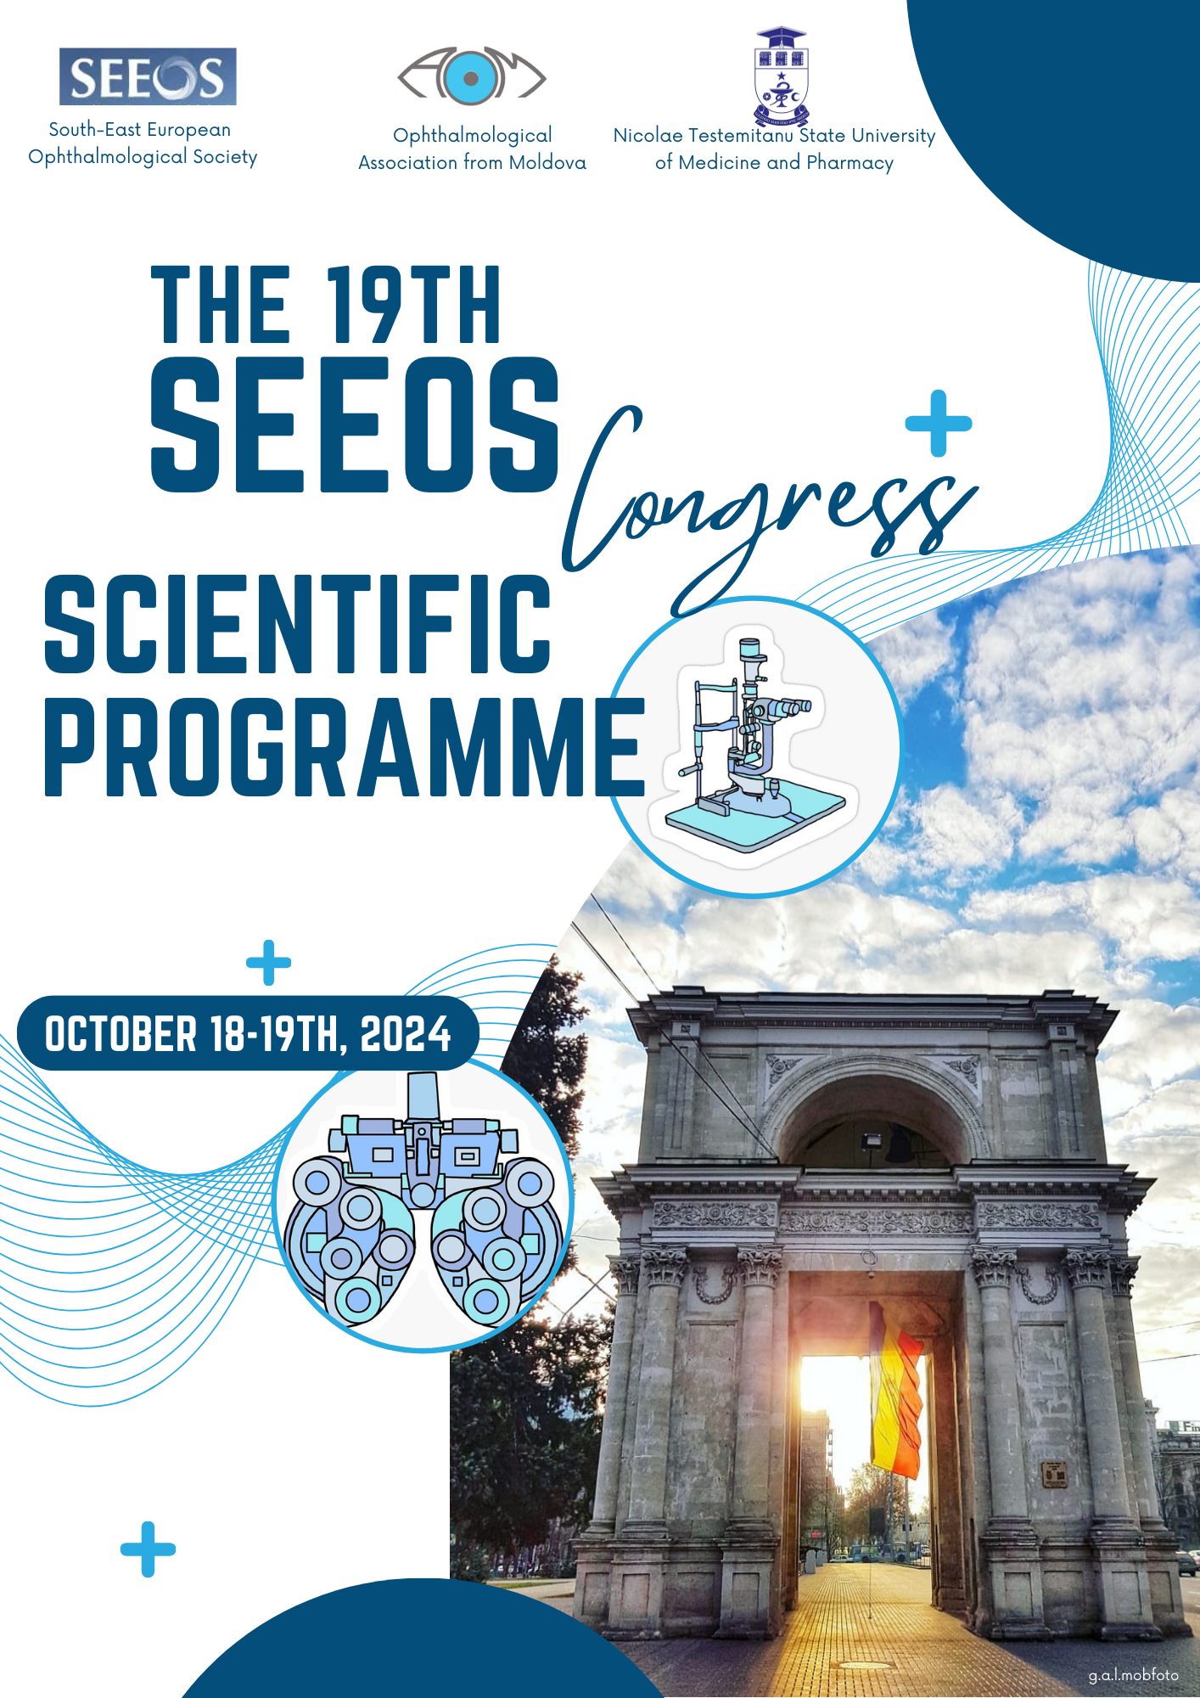

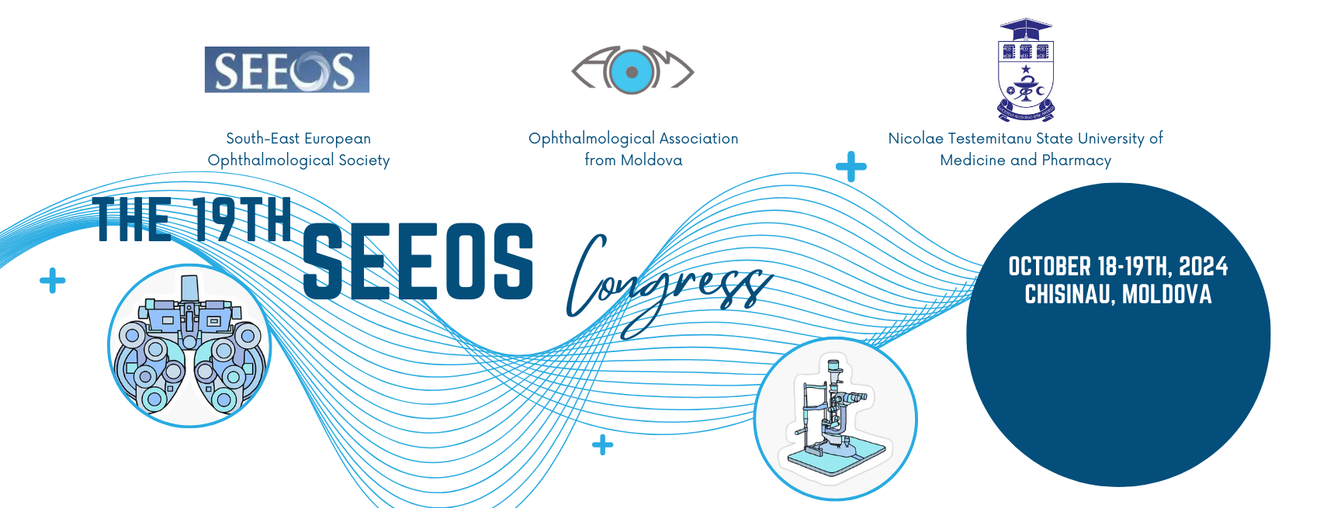

**Preliminary Program**

**19th South-East European Ophthalmological Society Congress**

|  |  |
| --- | --- |
| **18 OCTOBER 2024** | |
| 09:00 | **OPENING CEREMONY** |
| **SESSION I** | |
| **Moderators: Wolfgang Gindorfer, Mahmut Kaşkaloğlu, Eugeniu Bendelic** | |
| 09:30-09:45 | Wolfgang Gindorfer  *Regional Chair – Europe*  *International Agency for the Prevention of Blindness (IAPB)*  ENDING AVOIDABLE SIGHT LOSS’ WORKING TOGETHER FOR A WORLD WHERE EVERYONE HAS UNIVERSAL ACCESS TO EYE CARE |
| 09:45-09:55 | Tatiana Ghidirimschi1, Valentina Suruceanu1, Eugeniu Bendelic2, Corina Magdei2  *1LOW VISION Center, Chișinău, Republic of Moldova*  *2Department of ophthalmology, State University of Medicine and Pharmacy “Nicolae Testemițanu”*  *Republic of Moldova*  EYE HEALTH IN THE REPUBLIC OF MOLDOVA: ARGUMENTS FOR A NATIONAL PROGRAM |
| 09:55-10:10 | Mahmut Kaşkaloğlu  *Kaşkaloğlu Eye Hospital*  *Turkey*  INTRAOCULAR LENSES FOR MACULAR DEGENERATION |
| 10:10-10:25 | Tansu Erakgün  *Kaşkaloğlu Eye Hospital*  *Turkey*  INTRASCLERAL IOL IMPLANTATION IN TRANSCONJUNCTIVAL ERA |
| 10:25-10:35 | Radu Ochinciuc  *Retina Eye Clinic*  *Ophtamax Eye Hospital*  *Romania*  SCLERAL FIXATED IOL- COMPLICATIONS, SOLUTIONS, TECHNIQUES |
| 10:35-10:45 | Gheorghe Ivanov1,2; Irina Russu 1,2; Iuliana Saptefrati 1,2; Ion Jeru 2  *1Ovisus Medical Centre*  2*Nicolae Testemițanu State University of Medicine and Pharmacy, Department of Ophthalmology*  *Republic of Moldova*  ANTERIOR SEGMENT RECONSTRUCTION AND IRIS LOSS REPAIR IN PATIENTS WITH TRAUMATIC APHAKIA |
| 10:45-10:55 | *ALCON*  FROM MULTIFOCAL IOLS TO EXTENDED DEPTH OF FOCUS: THE BENEFITS OF ALCON VIVITY |
| 10:55-11:05 | *LENSES GRUP*  BINOCULAR IMPLANTATION OF MULTIFOCAL IOLS - EXPECTATIONS AND REALITY. OUR ACQUAINTANCE WITH PENTAFOCAL IOLS |
| 11:05-11:15 | *LENSES GRUP*  *STELLARIS PC, BAUSCH & LOMB* |
| 11:15-11:25 | *SIFI* |
| 11:25-12:00 | Coffee-break |
| **SESSION II** | |
| **Moderators:** **Bobrova Nadiya F., Natasa Vidovic Valentincic, Camelia Margareta Bogdănici, Valeriu Cușnir** | |
| 12:00-12:20 | Nadiya Bobrova F.  *Ukraine*  INTRASTROMAL CORNEOSCLERAL EPITHELIAL CYST. |
| 12:20-12:30 | Cuneyt Karaarslan  *Turkey*  UPCOMING ETHICAL AND LEGAL CHALLENGES FOR TWO PROMISING INNOVATIONS IN THE FIELD |
| 12:30-12:40 | Vitalie Procopciuc 1 , Valeriu Cușnir 1 , Viorel Nacu 2 , Lilia Dumbrăveanu 1 , Valentina Lupan 1 , Adrian Cociug 2 , Aurel Rusu 1 , Olga Perlog 1  *1 Department of Ophthalmology and Clinical Optometry,”Nicolae Testemițanu” State University of Medicine and Pharmacy*  *2 The Laboratory of Tissue Engineering and Cell Cultures, ”Nicolae Testemițanu” State University of Medicine and Pharmacy*  *Republic of Moldova*  OCULAR SURFACE PATHOLOGIES AND TISSUE TRANSPLANTATION IN THE DEPARTMENT OF OPHTHALMOLOGY AND CLINICAL OPTOMETRY |
| 12:40-12:55 | Baha Toygar  *BAU School of Medicine*  *Ophthalmology Department & Etiler Dünya Eye Hospital*  *Turkey*  ICL IMPLANTATION AND EXPLANTATION TECHNIQUES. NEW APPROACHES |
| 12:55-13:05 | Vera Chiriac, Rodica Bilba, Cristina Cosula, Stelian Curca, Errica Spoiala, Tatiana Radcova  *Medical Center Oculus Prim*  *Republic of Moldova*  CROSSLINKING FOR KERATOCONUS AND OTHER CORNEAL DISEASES |
| 13:05-13:15 | Camelia Margareta Bogdănici, Vlad Constantin Donica, Irina Andreea Pavel  *Discipline of Ophthalmology, ”Grigore T. Popa” University of Medicine and Pharmacy*  *România*  MYOPIA EPIDEMIC: NEW TREATMENT METHODS |
| 13:15-13:25 | Hugo Pena-Verdeal 1,2, Veronica Noya-Padin 1,2, Noelia Nores-Palmas 1,  Maria J. Giraldez 1,2, Eva Yebra-Pimentel 1,2  *1 Applied Physics Department (Optometry Area), Faculty of Optics and Optometry, Universidade de Santiago de Compostela (USC)*  *2 Optometry Group, Institute for Health Research Santiago de Compostela (IDIS),*  *Spain*  RANDOMIZED SIX-MONTH TRIAL OF ASPHERIC VS. EDOF CONTACT LENSES FOR PEDIATRIC MYOPIA CONTROL |
| 13:25-13:35 | Cristina Scerbatiuc  *Department of ophthalmology, ”Nicolae Testemițanu” State University of Medicine and Pharmacy*  *Republic of Moldova*  ORTHOKERATOLOGY IN MIOPIA MANAGEMENT |
| 13:35-13:45 | Natasa Vidovic Valentincic  *Eye Hospital, University Medical Centre*  *Faculty of Medicine, Universty of Ljubljana*  *Slovenia*  EMERGING TREATMENT POSSIBILITIES IN NONINFECTIOUS OCULAR INFLAMMATION: WHAT'S ON THE HORIZON? |
| 13:45-13:55 | *PROMOFARM*  DRY EYE SYNDROME |
| 13:55-14:05 | *ROMPHARM*  ANTISEPTICS IN OPHTHALMOPEDIATRIC PRACTICE |
| 14:05-14:15 | *MCI*  CLINICAL RESULTS OF TRANS PRK VISION CORRECTION |
| **SESSION III** | |
| **Moderators: Linda Zangwill, Edita Files Bradaric, Vesna Dimovska, Ion Jeru** | |
| 14:15-14:30 | Linda Zangwill  *USA*  GLAUCOMA AND MYOPIA: HOW TO DECIDE? |
| 14:30-14:45 | Linda Zangwill  *USA*  AI FOR IMPROVING GLAUCOMA MANAGEMENT: OPPORTUNITIES AND CHALLENGES |
| 14:45-15:05 | Nadiya F. Bobrova  *Ukraine*  FILTRATIVE SURGERY- VISCOSINUSOTRABECULOTOMY OF CONGENITAL GLAUCOMA ASSOCIATED WITH STURGE-WEBER-KRABBE SYNDROME |
| 15:05-15:15 | Edita Files Bradaric  *Eye clinic “Optimal”*  *Montenegro*  SELECTIVE LASER TRABECULOPLASTY FOR THE TREATMENT OF GLAUCOMA |
| 15:15-15:25 | Petja Vassileva 1, Yordanka Kirilova 2  *1 Specialized Eye Hospital “Acad. Pashev”,*  *2 Specialized Eye Hospital “Acad. Pashev”*  *Bulgaria*  POTENTIAL ROLE OF AI IN DIAGNOSIS OF LOW TENSION GLAUCOMA |
| 15:25-15:35 | Vesna Dimovska  *School of Medicine, University “St.Cyril and Methodius”*  *Hospital group “Promedika/Sistina Ophthalmology”*  *Macedonia*  THE ROLE OF MACULAR THICKNESS MEASUREMENTS IN DIAGNOSING GLAUCOMA AND PROGRESSION ASSESSMENT |
| 15:35-15:45 | Rodica Sevciuc 1, Virgilia Cosovan 1, Veronica Chisca 1, Victoria Tcaci 1, Tatiana  Ghidirimschi 2, Natalia Corduneanu 3  *1 Ophtalmological Department, Institute of Emergency Medicine*  *2 LOW VISION Centre*  *3 MedClinic International*  *Republic of Moldova*  SECONDARY GLAUCOMA IN IRIDOCORNEAL ENDOTHELIAL SYNDROME |
| 15:45-15:55 | Irina Celac 1, Aglaia Lobcenco 1, Eugeniu Bendelic 2  *1 Ophtalmology Clinic Republic Hospital “T.Moșnega”*  *2 University of Medicine and Pharmacy “N.Testemițanu”, Deparment of Oftalmology*  *Republic of Moldova*  EFFECTIVENESS OF SAR INTERVENTION IN THE TREATMENT OF REFRACTORY GLAUCOMA |
| 15:55-16:05 | Natalia Palarie ¹², Natalia Palii ¹  *¹Department of Ophthalmology, International Clinic*  *²Department of Biochemistry and Clinical Biochemistry, Nicolae Testemitanu State University of Medicine and Pharmacy,*  *Republic of Moldova*  COMBINATION OF ANTI-VEGF INJECTIONS AND MICROSECOND PULSE CYCLOPHOTOCOAGULATION IN THE MANAGEMENT OF NEOVASCULAR GLAUCOMA |
| 16:05-16:15 | *WORLD MEDICINE*  TRELIFE IN THE TREATMENT OF DRY EYE SYNDROME |
| 16:15-16:25 | *KEMBLI-MED*  MEDICONTUR INTRAOCULAR LENSES |
| 16:25-16:45 | Coffee break |
| **SESSION IV** | |
| **Moderators: Vincenzo Ferrara, Florian Balta, Daniela Selaru, Lilia Dumbraveanu** | |
| 16:45-17:00 | Vincenzo Ferrara  *Italy*  CUSTOMIZATION AND GOOD RATIONALE OF PRIMARY MACULAR HOLE SURGERY |
| 17:00-17:15 | Vincenzo Ferrara  *Italy*  VITREORETINAL SURGERY AND POST-OPERATIVE POSITIONING |
| 17:15-17:25 | Florian Balta, George Balta  *"Carol Davila“ University of Medicine and Pharmacy*  *Romania*  RHEGMATOGENOUS RETINAL DETACHMENT WITH CLOSED FUNNEL AND ADVANCED PROLIFERATIVE VITREORETINOPATHY |
| 17:25-17:35 | Nicolae Bobescu, Vitalie Cusnir, Lilia Dumbraveanu, Doina Bobescu, Doinita Tabaranu, Valeriu Cusnir  *Nicolae Testemițanu State University of Medicine and Pharmacy, Department of Ophthalmology and Optometry*  *Republic of Moldova*  FOUR-POINT FIXATION OF A SINGLE PIECE IOL AFTER POSTERIOR VITRECTOMY |
| 17:35-17:45 | Radu Ochinciuc  *Retina Eye Clinic*  *Romania*  RHEGMATOGENOUS RETINAL DETACHMENT ASSOCIATED WITH CHOROID DETACHMENT |
| 17:45-17:55 | Radu Ochinciuc  *Retina Eye Clinic*  *Romania*  CENTRAL SEROUS CHORIORETINOPATHY - WHAT SOLUTIONS DO WE HAVE |
| 17:55-18:05 | Polona Zaletel Benda1, Vladimir Debelič1, Darja Dobovšek Divjak1, Mojca Globočnik Petrovič1,2, Polona Jaki Mekjavić1,2, Alenka Lavrič Groznik1, Marko Šulak1, Mojca Urbančič1,2, Špela Markelj 1  *1Department of Ophtalmology, University Medical Centre Ljubljana*  *2Faculty od Medicine, University of Ljubljana*  *Slovenia*  COATS DISEASE: ANALYSIS OF SLOVENIAN PATIENTS |
| 18:05-18:15 | Ana Ursula Gavric, Polona Zaletel Benda, Natasa Valentincic, Polona Jaki Mekjavic  *Eye Hospital, University Medical Center Ljubljana*  *Slovenia*  BILATERAL VANCOMYCIN-ASSOCIATED HEMORRHAGIC OCCLUSIVE RETINAL VASCULITIS |
| 18:30 | **SEEOS Gala Dinner** |

|  |  |
| --- | --- |
| **19 OCTOBER 2024** | |
| **SESSION** | |
| **Moderators:** **Gazmend Kacaniku, Angela Corduneanu, Cahid Shazbazov** | |
| 09:00-09:10 | Dr. Cahid Shazbazov  *Caspian International Hospital*  *Azerbaijan*  FUNDAMENTALS AND SURGICAL PRINCIPLES OF AESTHETIC KERATOPIGMENTATION |
| 09:10-09:20 | Tatiana Ghidirimschi 1 , Hans Bjørn Bakketeig 2  *1 LOW VISION Center, Chișinău, Republic of Moldova*  *2 I Care – Norway, Norway*  LOW VISION REHABILITATION SERVICES IN THE REPUBLIC OF MOLDOVA: CURRENT LANDSCAPE AND FUTURE DIRECTIONS |
| 09:20-09:30 | Vdovichenko K.S., Bobrova N.F.  *Ukraine*  RECONSTRUCTIVE SURGERY IN OPEN GLOBE INJURIES IN UNUSUAL PEDIATRIC CASES |
| 09:30-09:40 | Angela Corduneanu1,2, Ala Paduca1, Rodica Ciala2, Elena Popov2  *1Ophthalmology Department, ”Nicolae Testemițanu” State University of Medicine and Pharmacy*  *2Ophthalmology Department, Republican Clinical Hospital “Timofei Mosneaga”*  *Republic of Moldova*  DIAGNOSTIC CONTROVERSIES IN OCULAR TRAUMA |
| 09:40-09:50 | Shylyk A.V., Bobrova N.F., Sorochynska T.A.  *Ukraine*  MODERN TECHNOLOGY IN INTRAVITREAL CHEMOTHERAPY OF RETINOBLASTOMA |
| 09:50-10:00 | Corina Magdei, Egor Porosencov, Crivceanschi Eugenia, Știrbu Alexandra, Țurcan Mariana  *Ophthalmology Department, “E. Coțaga” Clinic, Mother and Child Institute Republic of Moldova*  ORBITAL PSEUDOTUMOR IN A CHILD |
| 10:00-10:10 | *CENTRO IMPEX OPHTHALMOLOGICAL PORTFOLIO* |
| 10:10-10:20 | *LIQVOR*  *ZETOPTIC - SUPERIOR EFFICIENCY AND COMFORT IN GLAUCOMA TREATMENT* |
| 10:20-10:30 | *VITAPHARM* |
| 10:30-10:40 | Dovhan O.D., Bobrova N.F., Romanova T.V.  *Ukraine*  DIFFERENT CASES OF PERSISTENT PUPILLARY MEMBRANE IN PEDIATRICS |
| 10:40-10:50 | Irina Rotaru  *“Promed” Clinic*  *Republic of Moldova*  PAPILLEDEMA SECONDARY TO LYME NEUROBORRELIOSIS IN CHILDREN: A CASE REPORT |
| 10:50-11:00 | Elena Josan 1 , Valentina Lupan 1,2 , Mihaela Bostan 2  *1Ophthalmology and Microsurgery of the Eye Unit, “Sfânta Treime” Municipal Clinical Hospital*  *2Department of Ophthalmology and Optometry, “Nicolae Testemițanu” State University of Medicine and Pharmacy*  *Republic of Moldova*  EFFICACY AND SAFETY OF INTRAVITREAL ANTI-VEGF THERAPY WITH BEVACIZUMAB |
| 11:00-11:10 | Veronica Chişca, Angela Corduneanu, Natalia Ciobanu, Stanislav Groppa  *“Nicolae Testemitanu” State University of Medicine and Pharmacy*  *Institute of Emergency Medicine*  *Republic of Moldova*  VASCULAR ULTRASONOGRAPHIC AND ELECTROPHYSIOLOGICAL STUDY IN PATIENTS WITH DIABETIC RETINOPATHY |
| 11:10-11:20 | Victoria Verejan  *Department of Ophthalmology, N.Testemițanu State University of Medicine and Pharmacy*  *Republic of Moldova*  SIGNS OF TRAUMATIC OPTIC NEUROPATHY FOLLOWING MILD TRAUMATIC BRAIN INJURY IN SCHOOL-AGED CHILDREN |
| 11:20-11:30 | Cristina Scerbatiuc  *Department of ophthalmology, ”Nicolae Testemițanu” State University of Medicine and Pharmacy*  *Republic of Moldova*  KERATOCONUS MANAGEMENT WITH CORNEAL CROSSLINKING, EPI-ON METHOD |
| 11:30-11:40 | Florentina Verega  *Department of Ophthalmology, Nicolae Testemițanu State University of Medicine and Pharmacy*  *Ophthalmology Clinic „Microchirurgia ochiului”*  *Republic of Moldova*  THE FUTURE OF PRECISE AND SAFE EYE LASER TREATMENT |
| 11:40-11:50 | Loredana Pelevaniuc, Irina Verdeș, Olga Iasabaș  *Department of Ophthalmology, Nicolae Testemițanu State University of Medicine and Pharmacy*  *Republic of Moldova*  THE EVOLUTION OF PURULENT ENDOPHTALMITIS IN THE CONTEXT OF KLEBSIELLA PNEUMONIAE INFECTION |
| 11:50-12:00 | Valeriu Cușnir 12 , Lilia Dumbrăvenu 12 , Valentina Lupan 12 , Ana-Maria Storoja2 , Marina Strechi2  *1Ophthalmology and Microsurgery of the Eye Unit, “Sfânta Treime”; Municipal Clinical Hospital*  *2Department of Ophthalmology and Optometry, “Nicolae Testemitanu’’ State University of Medicine and Pharmacy*  *Republic of Moldova*  THE IMPACT OF RELIGIOUS FASTING ON OCULAR HEALTH |
| **18-19 OCTOBER 2024** | |
| **POSTER SESSION** | |
| **Moderators: Konovalova Nataliya, Wenger Ludmil, Ala Paduca, Sergiy Rykov** | |
| 1. ASSOCIATION OF BASELINE LEVELS OF INTERCELLULAR ADHESION MOLECULE-1 AND GLYCATED HAEMOGLOBIN WITH REPEATED TRANSSCLERAL CYCLOPHOTOCOAGULATION PROCEDURES IN PATHIENTS WITH DIABETIC NEOVASCULAR GLAUCOMA   Olga Guzun, Oleg Zadorozhnyy, Liudmyla Velychko, Oleksandra Bogdanova,Andrii Korol  *SI “The Filatov Institute of Eye Diseases and Tissue Therapy of the National Academy of Medical Sciences of Ukraine”*  *Odesa, Ukraine* | |
| 1. PECULIARITIES OF THE MOLECULAR MARKERS EXPRESSION ON PERIPHERAL BLOOD LYMPHOCYTES IN COMPLICATED RELAPSE OF RECURRENT IDIOPATHIC ANTERIOR UVEITIS   Khramenko NI, Velychko LM, Konovalova NV, Bogdanova OV  *SI "The Filatov Institute of Eye Diseases and Tissue Therapy of the National Academy of Medical Sciences of Ukraine"*  *Odesa, Ukraine* | |
| 1. CLINICAL COURSE OF UVEITIS OF TUBERCULOUS ETIOLOGY   1Konovalova Nataliya, 1Wenger Ludmila, 2Guzun Olga, 1Kovtun Aleksii  *1Odessa National Medical University*  *2 SІ “The Filatov Institute of Eye Diseases and Tissue Therapy of the National Academy of Medical Sciences of Ukraine”*  *Odesa, Ukraine* | |
| 1. FEATURES OF THE CONDITION OF THE PERILIMBAL TISSUES OF THE EYE DURING THE SURGICAL TREATMENT OF PATIENTS WITH OPEN-ANGLE GLAUCOMA   Iryna Shargorodska, Olha Sas  *Bogomolets National Medical University (NMU)*  *Kyiv, Ukraine* | |
| 1. STUDY OF THE ROLE OF P-SELECTIN IN THE DEVELOPMENT OF DIABETIC MACULAR EDEMA   Sergiy Rykov, Dmytro Chuhaiev  *Bogomolets National Medical University (NMU)*  *Kyiv, Ukraine* | |
| 1. ADVANSED CATARACT SURGERY   Vera Chiriac, Cornelia Ceban, Cristina Zabolotnii, Tatiana Radcova  *Medpark International Hospital*  *Chisinau, Republic of Moldova* | |
| 1. THE INFLUENCE OF VITAMIN D DEFICIENCY AND STRESS LEVEL ON THE DEVELOPMENT OF MYOPIA IN CHILDREN   Venger Anna  *Ophthalmology department, Odesa National Medical University,*  *Odesa, Ukraine* | |
| 1. CONTEMPORARY FEATURES OF THE ETIOPATHOGENETIC TREATMENT OF PATIENTS WITH RED EYE SYNDROME   L. O. Venger, N. V. Konovalova, S. I. Burdeinyi  *Odessa National Medical University*  *Odessa, Ukraine* | |
| 1. A STRATEGY FOR SLOWING THE PROGRESSION OF MYOPIA IN UKRAINIAN STUDENTS DURING DISTANCE LEARNING   1 Guzun O., 2 Bezdetko P., 1 Khramenko N., 3 Konovalova N., 1 Bushueva N.  *1 State Institution “The Filatov Institute of Eye Diseases and Tissue Therapy of the NAMS of Ukraine”, Odesa, Ukraine*  *2Kharkiv National Medical University, Kharkiv, Ukraine*  *3 Odesa National Medical University, Odesa, Ukraine* | |
| 1. HISTOLOGICAL CHANGES IN THE INTRAOCULAR STRUCTURES OF RABBIT EYES AFTER DIODE TRANSSCLERAL CYCLOPHOTOCOAGULATION   Guzun Olga, Zadorozhnyy Oleg, Chechyn Petr, Artеmov Alexander, Chargui Wael, Korol Andrii  *State Institution “The Filatov Institute of Eye Diseases and Tissue Therapy of the NAMS of Ukraine”*  *Odesa, Ukraine* | |
| 1. TREATMENT OF ACUTE VASCULAR OPTIC NEUROPATHY   1 Konovalova Nataliya, 2 Guzun Olga, 2 Khramenko Nataliya, 3 Vasyuta Vera  1 *Odesa National Medical University, Odesa, Ukraine*  *2 SІ “The Filatov Institute of Eye Diseases and Tissue Therapy of the National Academy of Medical Sciences of Ukraine”, Odesa, Ukraine*  *3 Institute of Neurosurgery named after Acad. A.P. Romodanova National Academy*  *of Sciences of Ukraine, Kyiv, Ukraine* | |
| 1. THE POSSIBILITY OF DEVELOPING OPTIC NEURITIS IN PATIENTS WITH ANTERIOR IRIDOCYCLITIS   1 Konovalova Nataliya, 1 Wenger Ludmil, 2 Guzun Olga, 1 Kovtun Aleksii  *1 Odesa National Medical University, Odesa, Ukraine*  *2 SІ “The Filatov Institute of Eye Diseases and Tissue Therapy of the National Academy of Medical Sciences of Ukraine”, Odesa, Ukraine* | |
| 1. EYE CHANGES OBSERVED IN THE FIRST YEARS AFTER A RADIATION DISASTER: SOME RESULTS OF THE REANALYSIS   Fedirko P. 1 , Babenko T. 1 , Pilmane M. 2 , Garkava N. 3 , Dorichevska R. 1  *1 Institute of Radiation Hygiene and Epidemiology, National Research Center for Radiation Medicine, Hematology and Oncology of the National Academy of Medical Sciences of Ukraine, Kyiv, Ukraine*  *2Department of Morphology, Rīga Stradziņš University, Rīga, Latvia*  *3Department of Ophthalmology, , Dnipro State Medical University, Dnipro, Ukrain* | |
| 1. OPTIC ATROPHY IN CHILDREN ASSOCIATED WITH PROGRESSIVE HEARING LOSS.CLINICAL CASE AND REVIEW OF LITERATURE   Mazur Liubovi, Cuznet Ludmila  *Department of Ophthalmology ,Discipline of Pediatric Neurology. IMSP Institute of Mother and Child Health Care*  *Chisinau, Moldova* | |
| 1. NON-PENETRATING SURGERY IN THE TREATMENT OF NEOVASCULAR GLAUCOM   Aglaia Lobcenco, Irina Chetrari  *Ophtalmology Clinic Republic Hospital “T.Moșneaga”*  *Chisinau, Republic of Moldova* | |
| 1. QUANTITATIVE ANALYSIS OF CHOROIDAL PARAMETERS IN PATIENTS WITH SYSTEMIC SCLEROSIS   Alina Moscalciuc¹׳², Angela Corduneanu¹׳², Agachi Svetlana³, Maria Iacubitchii²  *1. Republic Clinical Hospital „Timofei Mosneaga“, Department of Ophthalmology*  *2. State University of Medicine and Pharmacy „Nicolae Testemitanu“, Department of Ophthalmology*  *3. State University of Medicine and Pharmacy „Nicolae Testemitanu“, Department of Rheumatology*  *Chisinau, Republic of Moldova* | |
| 1. FEATURES OF MICROSURGICAL TREATMENT IN PATIENTS WITH PTERYGIUM.   Victoria Fandofan ,Uliana-Ariadna Bozul, Ion Jeru  *Department of Ophthalmology, USMF "Nicolae Testemițanu"*  *Chișinau ,Republic of Moldova* | |
| 1. SCLERAL LENSES IN CORNEAL DYSTROPHIES, SPECIFICALLY KERATOCONUS   Minina Tatiana  *Department of Ophthalmology and Clinical Optometry, ”Nicolae Testemițanu” State University of Medicine and Pharmacy*  *Chisinau, Republic of Moldova* | |
| 1. SOLUTIONS IN RESOLVING MYOPIA MANAGEMENT BY INDICATING CUSTOMIZED ORTHOKERATOLOGY LENSES   Adriana Gritcoˡ, Rodica Bîlbaˡ  *ˡDepartment of Ophthalmology and Optometry, "Nicolae Testemitanu" State University ofMedicine and Pharmacy*  *CM "OftalmElit"*  *Chisinau, Republic of Moldova* | |
| 1. BENEFITS OF BILATERAL CATARACT SURGERY IN THE SHORT INTEROPERATIVE PERIOD.   Tanurcova Iulia, Bendelic Eugeniu  *Department of Ophthalmology, Republican Clinical Hospital*  *Chisinau, Republic of Moldova* | |
| 1. INFLUENCE OF ANTIGLAUCOMA SHUNT ON PROTEINS LEVELS IN AQUEOUS HUMOR   Maria Iacubitchii1, Ala Paduca1, Eugeniu Bendelic1, Valeriana Pantea2, Oleg Arnaut3  *1Ophthalmology Department, ”Nicolae Testemiţanu” State University of Medicine and Pharmacy*  *2Biochemestry Laboratory, ”Nicolae Testemiţanu” State University of Medicine and Pharmacy*  *3Department of Human Physiology and Biophysics, ”Nicolae Testemiţanu” State University of Medicine and Pharmacy*  *Chisinau, Republic of Moldova* | |
| 1. POST TRAUMATIC LENS NEOVASCULARIZATION MANAGED BY ULTRASOUND BIOMICROSCOPY   Papanaga Marina 1,2, Corduneanu Angela 1,2, Mario De La Torre 3, Chiaburu A. 4, Bendelic Eugeniu 1,2  *1 Ophthalmology Department, “Nicolae Testemițanu” State University of Medicine and Pharmacy*  *2 Ophthalmology Department, “Timofei Moșneaga” Republican Clinical Hospital*  *3 Ophthalmology Department, The National University of San Marcos, Peru*  *4 Ophthalmology Department, “E. Coțaga” Clinic, Mother and Child Institute*  *Republic of Moldova* | |
| 1. THE IMPACT OF TORIC IOL IMPLANTATION ON PATIENTS' QUALITY OF LIFE   Iuliana Șaptefrați, G. Ivanov, Irina Russu, I. Jeru  *Ovisus Medical Center*  *Nicolae Testemițanu State University of Medicine and Pharmacy, Department of Ophthalmology*  *Chisinau, Republic of Moldova* | |
| 1. *OBJECTIVE METHODS OF REFRACTION EXAMINATION*   Petriman Daniela  *Department of Optometry-Ophthalmology “Nicolae Testemițanu” State University of Medicine and Pharmacy*  *Chisinau, Moldova* | |
| 1. OCULAR INJURY AFTER LASER-ASSISTED EYEBROW HAIR REMOVAL   Rodica Ciala¹, Alina Moscalciuc¹˒², Ala Paduca², Angela Corduneanu¹˒²  *1Ophthalmology Department, Republican Clinical Hospital “Timofei Mosneaga”*  *2 ”Nicolae Testemițanu” State University of Medicine and Pharmacy*  *Chisinau, Republic of Moldova* | |
| 1. RESULTS OF REFRACTIVE LENS EXTRACTION WITH EDOF IOL IMPLANTATION IN PATIENTS WITH HIGH MYOPIA AND MYOPIC ASTIGMATISM   Serghei Porada, AlexandraCucereavaia, Ala Paduca  *Department of Ophthalmology, Republican Clinical Hospital*  *Chisinau, Republic of Moldova* | |
| 1. CONTEMPORARY TREATMENT STRATEGIES FOR DIABETIC RETINOPATHY   Cristina Draganel, Lilia Dumbrăveanu, Vitalie Cușnir, Valeriu Cușnir  *Department of Ophthalmology and Clinical Optometry,”Nicolae Testemițanu” State University of Medicine and Pharmacy*  *Chisinau, Republic of Moldova* | |